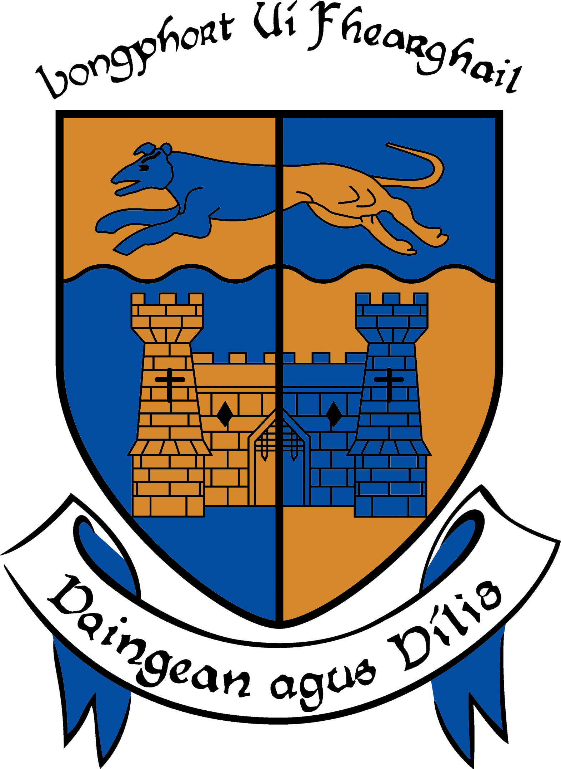

LONGFORD COUNTY COUNCIL

COMHAIRLE CHONTAE LONGFOIRT

Minutes of April and May (Combined) Monthly Meetings of Longford County Council
held in the Council Chamber, Aras an Chontae, Great Water Street, Longford on
Thursday, 1st May 2014 at 4.00 p.m.

PRESIDING: Councillor Larry Bannon, Mayor.

MEMBERS PRESENT: Councillors – Gearoid O Bradaigh, John Browne,
Mick Cahill, Micheál Carrigy, Mark Casey, Paul Connell, John Duffy, Sean Farrell Frank Kilbride, Donncha Mac Gleannáin, Victor Kiernan, Padraig Loughrey,
Luie McEntire, Martin Mulleady, Colm Murray, Peggy Nolan, P.J Reilly, Mae Sexton, Barney Steele and Thomas Victory.

IN ATTENDANCE: Mr. Tim Caffrey, County Manager.
Mr. Barry Lynch, Head of Finance/Director of Services.
Mr. Jack Kilgallen, Director of Services.
Mr. Frank Sheridan, Director of Services.

MEETINGS
ADMINISTRATOR: Ms. Anne Lee.

ADOPTION OF MINUTES.

On the proposal of Councillor F. Kilbride seconded by Councillor P. Connell, the Minutes of Monthly Meeting of Longford County Council held on the 19th March 2014 were confirmed and adopted.

On the proposal of Councillor P. Connell seconded by Councillor F. Kilbride, the Minutes of Special Meeting of Longford County Council held on the 9th April 2014 were confirmed and adopted.

MATTERS ARISING FROM MINUTES.

Organisational Review for Longford Local Authorities.

Councillor D. Glennon referred to his request at the March meeting of the Council that the report commissioned by the Council, through the Institute of Public Administration, a number of years ago be provided to Councillors before the end of this Council.

It was agreed that the draft report be circulated to the members.

PRESENTATION BY AGE FRIENDLY IRELAND.

Mayor Bannon welcomed Catherine McGuigan, Regional Programme Manager, Age Friendly Ireland.

Ms. McGuigan addressed the members regarding the Age Friendly Initiative for County Longford under the following headings -

- More people living longer, living better.
- Context for County Longford.
- Global effort to make a real difference – led by World Health Organisation.
  - Framework for developing age friendly communities.
  - Dublin Declaration signed 2011/2013.
- Where we live impacts on How we live.
- Meaning of Age Friendly –
  - Outdoor spaces & buildings.
  - Transportation.
  - Housing.
  - Social Participation.
  - Respect & Social Inclusion.
  - Civic Participation & Employment.
  - Communication & Information.
  - Community Support & Health Services.
- Age Friendly County –
  - Local collaboration.
  - Local consultation.
  - Joined up, real change.
- Need for a National Programme.
- National team supporting local alliances.
- Becoming an Age Friendly County.
- National Initiatives delivered through Age Friendly Counties.
- Local County initiatives achieving key outcomes.
- Age Friendly Business Forum.
- Men’s Shed Programme.
- Bogus Caller Scheme.

On the proposal of Councillor P. Nolan seconded by Councillor J. Duffy, it was unanimously agreed that Longford County Council support the Age Friendly Initiative for County Longford. Ms. McGuigan thanked the Mayor and Members for their support.

CORPORATE POLICY GROUP MINUTES.

The adopted Minutes of Corporate Policy Group Meetings held on the 19th February 2014, which had been circulated, were noted.

MANAGER’S ORDERS

The County Manager’s Orders, which had been circulated, were noted.

ECONOMIC AND COMMUNITY DEVELOPMENT, CORPORATE,
CULTURAL & RECREATIONAL SERVICES, HUMAN RESOURCES,
PLANNING & BUILDING CONTROL.

Planning Applications

The list of Planning Applications received since the March meeting of the Council was submitted and noted.

Minutes of Meeting of Housing & Social Policy, Planning & Building Control Policy Strategic Policy Committee held on the 24th September 2013.

The Minutes of Meeting of Housing & Social Policy, Planning & Building Control Policy Strategic Policy Committee held on the 24th September 2013, as circulated, were noted.

Date for First Annual Meeting of Longford County Council following 2014 Local Elections.

The meeting was informed that in accordance with Section 3(1) of Schedule 10 of the Local Government Act 2001, the Annual Meeting of the Council will be held on Friday,
6th June 2014.

On the proposal of Councillor F. Kilbride seconded by Councillor S. Farrell, it was agreed that the First Annual Meeting of the new Council be held on Friday, 6th June 2014 at
2.00 p.m.

Draft Annual Report 2013

On the proposal of Councillor P. Nolan seconded by Councillor F. Kilbride, it was unanimously agreed to adopt the Draft Annual Report 2013, as circulated.

Grants to Community and Voluntary Bodies 2014.

On the proposal of Councillor J. Duffy seconded by Councillor C. Murray, it was agreed to adopt the list of Grants to Community and Voluntary Bodies 2014, as circulated.

Dissolution of County Development Board.

Councillor M. Carrigy proposed and Councillor J. Duffy seconded the dissolution of the County Development Board.

Establishment of Local Community Development Committees.

Mr. F. Sheridan, Director of Services, outlined details of report as circulated, regarding the proposed membership of the Local Community Development Committee and the main functions of the LCDC.

The members expressed concern regarding the fact that only three members from the Local Authority will be represented on the Committee.

The members accepted the framework for the establishment of the Local Community Development Committees but did not agree to the guidelines issued by the Department of the Environment, Community & Local Government. It was agreed that the establishment of the LCDC’s be considered by the new Council following the Local Elections.

On the proposal of Councillor M. Sexton seconded by Councillor D. Glennon, it was agreed that a letter be forwarded to the Minister for the Environment, Community & Local Government requesting increased representation from the Local Authority.

Establishment of Local Enterprise Office.

Mr. Sheridan informed the members regarding the establishment of the Local Enterprise Office. It was agreed that Mr. Michael Nevin, Head of Local Enterprise, be invited to attend a meeting of the Council to provide an update regarding the Local Enterprise Office.

Community Tourism Diaspora Project.

Mr. F. Sheridan, Director of Services, referred to the new Community Tourism Initiative which seeks to build on the legacy of The Gathering 2013. The initiative is a joint partnership between Failte Ireland, IPB Insurance and Local Authorities. The aim of the funding is to provide €1m annually over the next three years to support local community-based events and festivals. Each county will spend approximately €30,000 over the next three years for this purpose. The amount awarded to each event will be based on the number of overseas visitors that are likely to attend. The minimum grant is €500 and the maximum €3,000.

The closing date for receipt of applications is the 9th May 2014.

Councillor M. Carrigy outlined the details of the Walking Festival being held in the County over the May Bank Holiday weekend.

Provision of short term, refundable, finance to facilitate the construction of the Cycle Route along the Royal Canal from Longford Town to Richmond Harbour in Clondra.

On the proposal of Councillor P. Connell seconded by Councillor P. Nolan it was unanimously agreed to the provision of short term, refundable, finance to facilitate the construction of the Cycle Route along the Royal Canal from Longford Town to Richmond Harbour in Clondra.

Supplementary Register of Electors.

It was noted that the closing date for receipt of applications for inclusion on the Supplementary Register of Electors is the 6th May 2014 at 5.00 p.m.

Official Opening of Granard Market House Community Library.

Mr. Sheridan informed the meeting that the Granard Market House Community Library will be officially opened by Minister Phil Hogan on the 8th May 2014.

Playgrounds Programme.

A report was circulated regarding the provision of playgrounds in the County to date.

Count following Local Elections.

The meeting was informed that the counting of votes will be held at Clonguish GAA,
PJ Murphy Sports Complex, Newtownforbes commencing on the 24th May 2014.

Notices of Motions.

Retail Strategy for Longford Town.

The following Notice of Motion was proposed by Councillor J. Browne and seconded by Councillor M. Sexton -

“I ask the Planning Department of Longford County Council to prepare a report on the current retail strategy for Longford Town to confirm that the strategy prohibits large retail development outside the town centre area of Longford and to confirm what changes if any need to be made to the retail strategy or the Development Plan to make sure that any such development cannot obtain planning permission as this would be detrimental to the viable future of the town centre and to existing rate payers and businesses.”

Mr. F. Sheridan stated that the current retail strategy for Longford Town does not facilitate a large retail development outside the town centre area. Although the policy itself does not rule it out in itself, it is substantially controlled and guided by a recent Bord Pleanala decision refusing planning permission for such a development in Longford Town.

The retail strategy has been revised as part of the review of the County Development Plan 2015-2021. This revised strategy reflects the previous Bord Pleanala decision and current Departmental guidelines in this regard. The revised strategy substantially restricts large out of town retail developments.

Councillor M. Sexton proposed and Councillor M. Mulleady seconded that a letter be forwarded to the Minister for the Environment, Community & Local Government requesting that the preparation of future County Development Plans coincide with the formation of new Councils.

Investment and Job Opportunities in County Longford.

The following Notice of Motion was proposed by Councillor M. Casey and seconded by Councillor M. Sexton -

"I propose that this Council seeks a deputation with the IDA to highlight the growing lack of investment and job opportunities in Longford, which is causing high unemployment, emigration, poverty and depopulation of the county."

It was agreed that a letter be sent to the I.D.A. requesting a representative from the I.D.A. to attend a meeting of the Council.

INFRASTRUCTURAL, ENVIRONMENTAL & EMERGENCY SERVICES.

Taking in Charge of Road at the Templemichael Glebe Industrial Estate, Ballinalee Road, Longford.

On the proposal of Councillor M. Mulleady seconded by Councillor L. McEntire, it was unanimously to the Taking in Charge of the Road at the Templemichael Glebe Industrial Estate, Ballinalee Road, Longford as soon as the specified minimum works to an estimated value of €50,000 have been implemented.

Weight Restriction on L-5167-0 from its junction with the R393 at Cooleeny/Fereghfad to its junction with the N4 at Cooleeny

On the proposal of Councillor M. Mulleady seconded by Councillor F. Kilbride, it was unanimously agreed to the placing of a Weight Restriction on L-5167-0 from its junction with the R393 at Cooleeny/Fereghfad to its junction with the N4 at Cooleeny.

Notices of Motions.

Local Improvement Schemes.

The following Notice of Motion was proposed by Councillor F. Kilbride and seconded by Councillor L. McEntire -

“That 10% of the total roads budget be allocated to Local Improvement Schemes in the coming year.”
The following Notice of Motion was proposed by Councillor L. McEntire and seconded by Councillor F. Kilbride -

“That this Council now allocates the 15% funding from roads allocation towards Local Improvement Schemes as directed by the Minister for Transport or, in the event of a further allocation coming from the Department, that it be used for those schemes as residents on private roads have no other way to carry out repairs to their roads.”

The following Notice of Motion was proposed by Councillor M. Carrigy and seconded by Councillor F. Kilbride -

“I call on Longford County Council to allocate 15% of any additional discretionary funding which may come before the end of the year towards Local Improvement Schemes.”

The following Notice of Motion was proposed by Councillor J. Duffy and seconded by Councillor M. Carrigy -

“That this Council reintroduces the Local Improvement Scheme should more funding become available this year and that this Council passes a motion that it will be policy in 2015 that funding from the discretionary budget be used for this important scheme. This policy is allowed by the Department and is the case in neighbouring counties. There are residents in Longford who need this scheme as a matter of urgency to access their homes.”

Mr. J. Kilgallen, Director of Services, stated that the wording of the Department Circular RW 3/2014 relating to Local Improvement Schemes for 2014 is as follows -

“Local Authorities may use up to 15% of their initial Discretionary Grant (as allocated in January 2014) towards LIS’s should they wish to do so.”

It was clear to the Members in adopting the Draft Roadworks Scheme that conditions including salting/gritting and the necessary essential maintenance of Regional and Local roads precluded transferring scarce Discretionary funds from the public road network to private roads. However, the Council may, if agreed, write to the Minister to request sanction of further funding solely for LIS’s or as a portion of any additional available Discretionary funding.

It was agreed that a letter be forwarded to the Minister for Transport.

School Bus Parking Areas.

The following Notice of Motion was proposed by Councillor M. Carrigy and seconded by Councillor J. Duffy -

“I call on Longford County Council, in conjunction with Bus Eireann (School Transport Office), to erect safety signage in advance of official school bus parking areas.”

Mr. Kilgallen stated that the Road Design section will consult with Bus Eireann and the NRA as necessary to investigate the erection of any necessary signage as requested.

Meeting with the National Roads Authority.

On the proposal of Councillor M. Carrigy seconded by Councillor P.J. Reilly it was unanimously agreed to request the N.R.A. to defer the meeting arranged for the
9th May to a date following the local elections.

Public Lighting in Granard.

Councillor P.J. Reilly referred to the new energy lighting system in Granard and expressed concern regarding public safety.

It was agreed that a representative from the Design Team will meet with the local representatives in the area regarding the new public lighting system in Granard.

FINANCE & INFORMATION SYSTEMS, HOUSING & BUILDING.

Public Liability Claims.
It was noted that two public liability claims were received during March 2014.

Disposal of Freehold Interest of property at No. 57, The Demesne, Longford.

On the proposal of Councillor Martin Mulleady seconded by Councillor Frank Kilbride, it was unanimously agreed to dispose of Freehold Interest of property at No. 57, The Demesne, Longford to Mary Clancy in accordance with the terms of Section 183 of the Local Government Act 2001 issued on the 1st April 2014.

Taking in Charge of Housing Estates.

On the proposal of Councillor M. Mulleady seconded by Councillor F. Kilbride, it was unanimously agreed to the taking in Charge of the following housing estates -

- Barley Gardens, Abbeyshrule, Co. Longford.
- Cnoc na Gaoithe, Lanesboro, Co. Longford.
- An Rath Bheag, Abbeylara, Co. Longford.
- Bó Dearg, Aughadegnan, Longford.
- Railway Court, Newtownforbes, Co. Longford.
- Creevaghbeg, Ballymahon, Co. Longford.
- Lios na Gaoithe, Lisryan, Co. Longford.
- Cloverwell, Edgeworthstown, Co. Longford.
- Sliabh Rua, Drumlish, Co. Longford.

Notice of Motion.

Local Property Tax.

The following Notice of Motion submitted by Councillor Mark Casey was deferred to the June meeting of the Council –

“I propose that this Council writes to the Department of the Environment seeking clarification on why the funding provided by the people of Longford through the Local Property Tax has not made available to Longford County Council. This money was paid by the people of Longford in the belief that it was to be used for local amenities”.

General Items.

Notices of Motions.

Future of The Quinn Group.

The following Notice of Motion was proposed by Councillor J. Duffy and seconded by Councillor L. McEntire -

“The Quinn Group has long been a corner stone of economic prosperity and cultural identity in the northwest of Ireland. It's diversity, along with the synergies and efficiencies achieved by its sheer mass, has always been seen as key to its success.
The appointment of receivers to the group was a huge blow to the region. In spite of assurances given at the time that the group would not be sold off, it is clear that the groups component businesses will be broken up and disposed of.
The recent announcement of the sale of Quinn Roof Tiles to a Belfast company, the announcement of a sales process for the packaging business, the disposal of the fleet and the outsourcing of transport are clear indicators of the ultimate break up of the group and winding down of operations here in the border region.
I feel that keeping the group together and managing it locally is the the only way to insure the maximum return for the group's investors.
In light of the fact that there is currently at least one proposal to consolidate and manage the group locally, I call on the Board of Directors of Aventas Holding Ltd to pause any proposals to sell off or break up any part of the group until such time as all prospects of keeping the group intact and based in the area have been fully explored.”

It was agreed that a letter be forwarded to Aventas Holding Ltd.

Free Legal Aid Board - Minimum Charge.

The following Notice of Motion was proposed by Councillor Micheal Carrigy and seconded by Councillor P. Nolan -

“I call on the Legal Aid Board to revisit their decision to increase their minimum charge from €50.00 to €120.00 for certain instances.”

It was agreed that a letter be forwarded to the Legal Aid Board.

Correspondence - as circulated.

Correspondence dated 26th March and 15th April 2014 received from Mr. Joseph Ruane, Area Manager, Midlands Region, Health Service Executive regarding queries raised at Special Meeting of Longford County Council and Longford Town Council held on 29th January 2014 was noted. Councillor P. Nolan expressed disappointment with the replies received from
Mr. Ruane.

Letter dated 10th April 2014 received from the Department of Transport, Tourism and Sport regarding grant funding under the Active Travel Towns Funding Scheme was noted.

Correspondence dated 16th April 2014 received from the Office of the Minister for the Environment, Community and Local Government in relation to the Local Property Tax was noted.

Conclusion.
Councillor Larry Bannon, stated that it had been a privilege to serve as Mayor and thanked the Elected Members, the County Manager, the Directors of Services, the Meetings Administrator and all the staff for their help and assistance over the last year.

He thanked the Deputy Mayor, Councillor Frank Kilbride, for his assistance during the year and also thanked the local media – the Longford Leader and Shannonside for their coverage of events during the previous twelve months.
Councillor Bannon referred to a number of highlights during the year.
The Members of the Council congratulated the outgoing Mayor on his very successful year.
Mr. Tim Caffrey, County Manager on his own behalf and on behalf of the staff of the Council congratulated Mayor Bannon on his year as Mayor of the Council.

Retiring Members.
Best wishes were extended to Councillors Barney Steele, Gerry Brady, Victor Kiernan,
Denis Glennon and Larry Bannon on their retirement from Longford Count Council.

Vote of Sympathy.
On the proposal of Mayor L. Bannon seconded by Councillor D. Glennon, it was unanimously agreed that a vote of sympathy be extended to Ciaran Murphy on the death of his father.

Conferences

Report from Corporate Policy Group.

This concluded the business of the meeting.


Signed: _______________
Anne Lee,
Meetings Administrator.

Confirmed and adopted at Monthly Meeting of Longford County Council held on the
18th June 2014.

Signed: _______________
Mayor.

